**Task 2 – SQL Basics- 23-08-2023**

**Question 1:**

Create a Database product_db

**Output:**

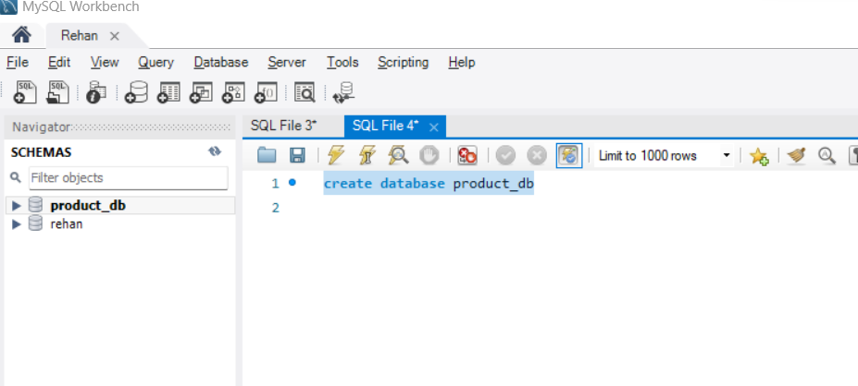

**Query:**

**create database product_db;**

**Question 2:**

Create a table with the name "product" with the following columns product_id - integer ,product - string - size 10,quantity - integer,price - integer,purcahase_cost – integer , estimated_sale_price – float

**Output:**

**Query:**

**create table product ( product_id int,product varchar(10),quantity int , price int, purcahase_cost int, estimated_sale_price float );**

**Question 3:**

Display all column names and their datatype and size in product.

**Output:**

**Query: desc product;**

**______________________________________________________________________________**

**Question 4:**

Insert the below two records into product table.

**

**Query:**

**insert into product(product_id,product,quantity,price,purcahase_cost,estimated_sale_price) values (1,'PayCard',2,300,8000,9000.56);**

**insert into product(product_id,product,quantity,price,purcahase_cost,estimated_sale_price) values (2,'PayPoints',4,200,7000,6700.56);**

**Question 5:**

Add a column: "location" to the existing product table with data type varchar and size 50

**Output:**

**Query: Alter table product add column location varchar(50);**

**Question 6:**

**Update the value of the location**

**Output:**

**Query:**

**update product set location = 'USA' where product_id = 1;**

**update product set location = 'India' where product_id = 2;**

**Question 7:**

**What is the value of location for product : ‘PayCard’?**

**Output:**

**Query :** **SELECT product , LOCATION from product where product = 'PayCard'**

**Question 8:**

**update the product column to size of 25**

**Output:**

**Query: alter table product modify column product varchar(25);**

**Question 9:**

**Reduce the size of the location field from 50 to 20 and check if it is possible.**

**Output:**

**Query: alter table product modify column location varchar(25);**

**Question 10:**

**Update the quantity information of ‘PayCard’ product details . -- For ‘PayCard’ product, Update the quantity from 2 to 10**

**Output:**

**Query: update product set quantity = 10 where product = 'PayCard';**

**Question 11:**

**insert one more row/record to the table**

**Output:**

**Query: insert into product(product_id,product,quantity,price,purcahase_cost,estimated_sale_pri ce,location) values (3,'Creditcard',2,500,900,750,'India');**

**Question 12:**

**insert below two row/record to the table by using one query**

**Output:**

**Query: insert into product(product_id,product,quantity,price,purcahase_cost,estimated_sale_price,location) values (4,'Debitcard',4,500,2000,1850,'UK'),(5,'Buyback',20,500,10000,9800.85,'USA');**

**Question 13:**

**add a column zip_code to the product table**

**Output:**

**Query: alter table product add column Zip_Code int;**

**Question 14:**

**update zip_code to the product table by some random unique zip code to the product**

**Output:**

**Query:**

**update product set Zip_Code = '600050' where product_id in (1,3);**

**update product set Zip_Code = '600051' where product_id in (2,4);**

**update product set Zip_Code = '600052' where product_id in (5);**

**Question 15:**

**drop the column zip_code from the table**

**Output:**

**Query: alter table product drop column Zip_Code ;**